NAME: MUHMMAD Kaleem

SAPP: 56614

COURSE: DBMS

TASK 1:

**QUESTION:** Display the report of all those employees whose income is less than those who work in any department numbers 50, 20, and 10.

**OUTPUT:::::::**

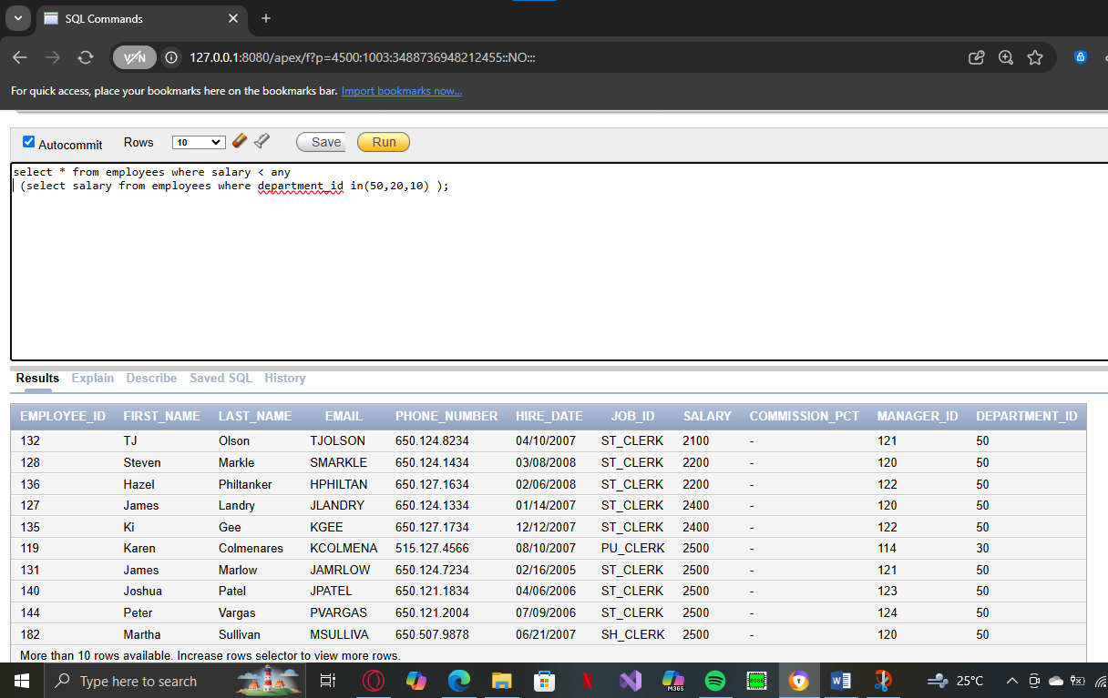

TASK 2:

**QUESTION:** The HR department needs a report that display the last name, department number, and job ID of alt employees whose department location ID is 1700.

**OUTPUT::::**

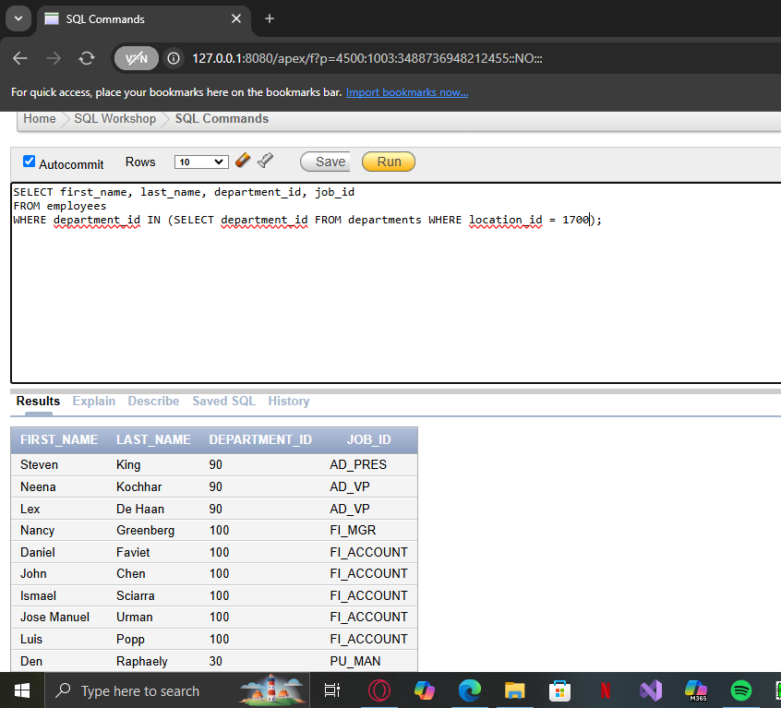

TASK 3:

**QUESTION:** Display the job number and job title of those employees whose maximum salary greater than 'ST MAN from job table.

**OUTPUT:::**

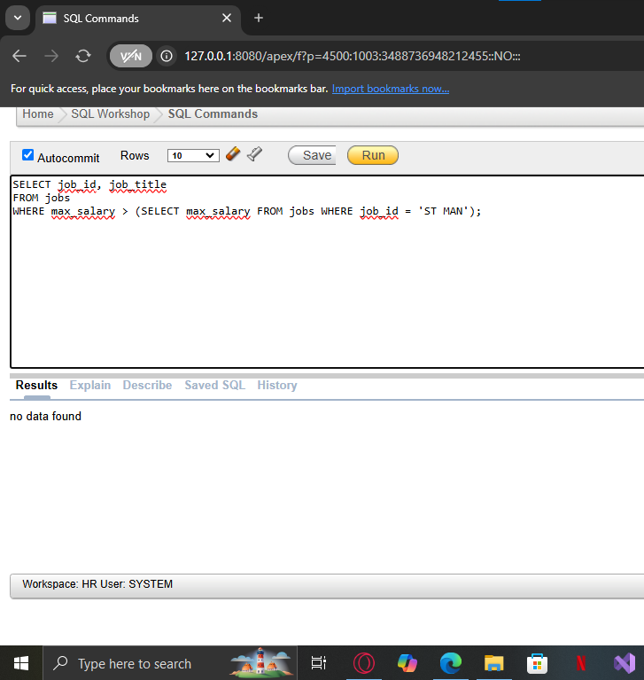

TASK 4:

**QUESTION**: Show a report that displays the employee number, first name, and salary of all employees who carn more than the average salary. Sort the results according to salary in ascending order.

**OUTPUT::**

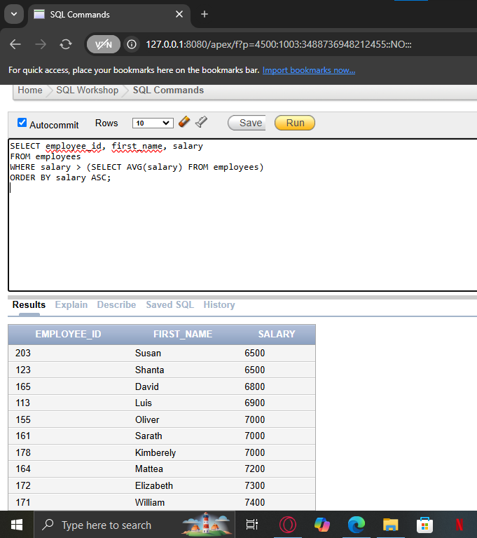

TASK 5:

**QUESTION:** Display all the departments that have a minimum salary greater than that of department 50.

**OUTPUT::::**

